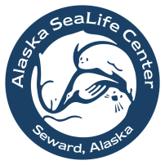

Alaska SeaLife Center Education Department

Day Program Reservation Form

Program Information:
Preferred date of field trip: |  | (M/D/Y)
Preferred arrival time:
(your program will begin 1 hour after you arrive)
Alternate Date/time:
Day Program reservations must be made at least 30 days in advance
Your first hour will be a self-guided tour, and your education program will take place during the second hour.
Total # Students:
Total # Adults:
Student grade level(s):
Program choice:
Information about our programs can be found on our website, www.alaskasealife.org
Cost is $25 per person, including admission to the SeaLife Center; minimum class charge is $300.
One adult is free for every 10 students.

To complete your reservation, a 50% deposit is required within 30 days of submitting this form.

Lead Teacher Information:
School/Organization:
Lead Teacher’s name:
Phone number:
E-mail address:
Alternate contact name:
Alternate contact phone or e-mail:
Billing Information:
School/Organization:
Contact Name:
Street address:
City, State, and Zip Code:
Phone:
E-mail address:
Organization Tax ID #:
Tax exempt? | Yes No

Please complete this form, save it and send it to education@alaskasealife.org,
or print it out and fax it to us at (907) 224-6320.

We will confirm your reservation via e-mail within 3-4 business days.

