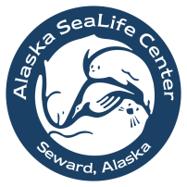

Education Programs

Nocturne Sleepover Reservation Form

Program Information:
Preferred date of arrival: |  | (M/D/Y)
2nd choice date: |  | (M/D/Y)
3rd choice date: |  | (M/D/Y)
Total # Students: |  | (max. 65 students)
Total # Adults: |  | (max. 15 adults)
Student grade level(s):
First Program selection:
Second Program selection:
Program descriptions are available at www.alaskasealife.org.
Cost is $65 per person March-August, $55 per person September-February.
Minimum of 12 paying participants; one chaperone is free for every 10 students.
To complete your reservation, a $600 deposit must be received within 30 days (or by January 15 for spring reservations).
IMPORTANT: No more than 80 people total in the sleeping area! This is a fire code, so any additional guests will be required to find other accommodations for the night.
Lead Teacher Information:
School/Organization:
Lead Teacher’s name:
Phone number:
E-mail address:
Alternate contact name:
Alternate contact phone or e-mail:
Billing Information:
School/Organization:
Contact name:
Street address:
City, State, and Zip Code:
Phone:
E-mail address:
Organization Tax ID #:
Tax exempt? | Yes No

Please complete this form and email it to education@alaskasealife.org (preferable),
or print it out and fax it to us at (907) 224-6320.

We will confirm your reservation via e-mail within 2-3 business days.

