Teacher’s Name
Email Address
School Name & Grade Level
Teacher’s Mailing Address
Contact Phone Number
Dietary Restrictions?
Gender |  | (Participants will be housed in double-occupancy rooms.  You may request to room with a participant you know.)
Are you interested in earning UAA credit? |  | (Note: A separate fee to UAA will be required.)
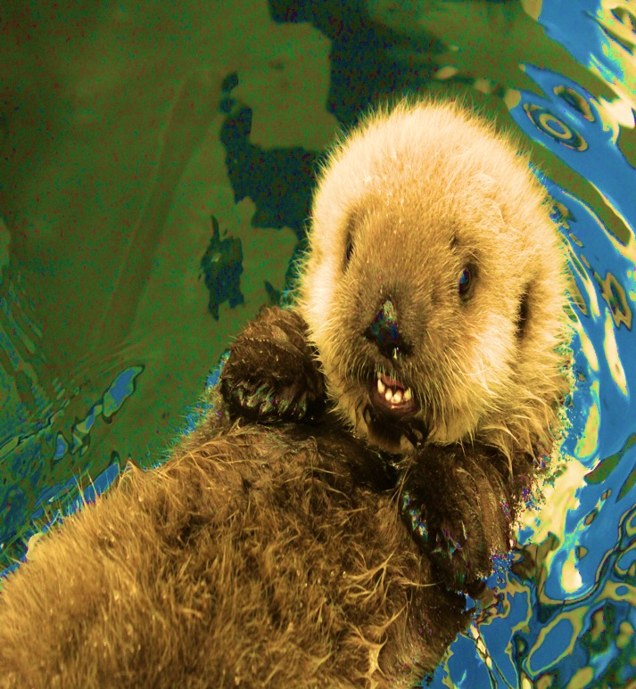
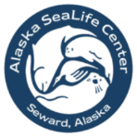
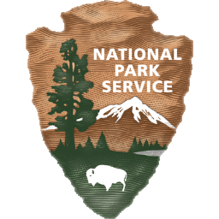
Registration form & $75 workshop fee due by: October 11, 2019
Teachers Workshop
Oct 18-20, 2019
at the Alaska SeaLife Center in Seward

Presented by: The National Park Service and the Alaska SeaLife Center

Ocean Tech:
Innovation, Technology and Tradition Under the Sea: Grades K-5
Join educators and researchers from the Alaska SeaLife Center and the National Park Service to learn about how scientists use technology to study the ocean and its inhabitants.
$75 workshop registration fee; lodging in Seward for two nights and all meals are provided thanks to the generous support of the National Park Service. Registration is limited and will be filled on a first-come, first-served basis. If you have any further questions, please contact the Alaska SeaLife Center Education Department at: 907-224-6306 or education@alaskasealife.org.
The hours of the workshop are:
Friday the 18th: 5:00pm-8:30pm, Saturday the 19st: 8:00am-5:00pm, & Sunday the 20th: 8:00am-3:30pm

Email this form to education@alaskasealife.org and call 907-224-6306 to pay with credit card.

